Warm-Up #4
- Name and write the function for each piece of lab equipment below:
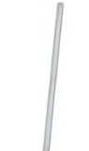
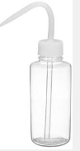
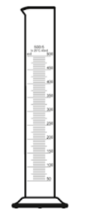
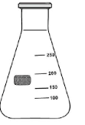
A. B. C. D.

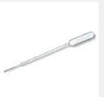
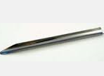
F. G. H.

- List the indicators of a chemical change/reaction:

- Name each substance. Identify each as element, ionic or covalent.
  - Na
  - CO
  - MgO
  - Co
  - S₂O₄
  - NBr₃
- Identify each mixture as homogeneous or heterogeneous.
  - Soda
  - Sand
  - Steel (carbon mixed with iron)
Warm-Up #4
- Name and write the function for each piece of lab equipment below:
A. B. C. D.

F. G. H.

- List the indicators of a chemical change/reaction:

- Name each substance. Identify each as element, ionic or covalent.
  - Na
  - CO
  - MgO
  - Co
  - S₂O₄
  - NBr₃
- Identify each mixture as homogeneous or heterogeneous.
  - Soda
  - Sand
  - Steel (carbon mixed with iron)

