Trends: Ion Charge in the Main Block Elements
Name:___________________________________________________________________ Block:__________
- Octet Rule states:
- If you change the (electrons/protons) in an atom, you change the identity of that atom ●The charge on an atom is due to the change in(electrons/protons)
Group | Element  That Represents the Group | Noble-Gas Notation  (Helps identify outer-most electrons) | # of valence e⁻ | Draw the  electron dot diagram | How many electrons must be gained to obey the octet rule? | How many electrons must be gained to obey the octet rule? | What is the easiest way to obey the octet rule? | Resulting in more protons or electrons? | Is it a cation or anion? | Ion Symbol | Trend  Main Block Elements Ion Charge | Electron Configuration of the ION  Identical to which noble gas | Atomic Size Change
1 | Na | [Ne]3s¹ | 1 | Na• | 7 | 1 | lose 1 e⁻ | 1 more p⁺ | cation  anion | Na⁺ | Group 1 IONS  have _1+_ charge | 1s²2s²2p⁶  Identical to _Neon_ | Smaller b/c lost e⁻ =more p⁺ than e⁻= more nucleus attraction
2 | Mg |  |  |  |  |  |  |  | cation  anion |  | Group 2 IONS  have ______ charge | _______________  Identical to ____________
13 | Al |  |  |  |  |  |  |  | cation  anion |  | Group 13 IONS  have ______ charge | _______________  Identical to ____________
14 | There is no trend for the Group 14 Elements. Lead (Pb) & Tin (Sn) are like most of the Transition Metals.
15 | P | [Ne] 3s²3p³ | 5 | 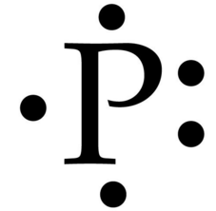 | 3 | 5 | gain 3 e⁻ | 3 more e⁻ | cation  anion | P³⁻ | Group 15 IONS  have _3-_ charge | 1s²2s²2p⁶3s²3p⁶  Identical to ____Argon___ | Bigger b/c gain e⁻  =more e⁻ than p⁺  = less nucleus attraction
16 | S |  |  |  |  |  |  |  | cation  anion |  | Group 16 IONS  have ______ charge | _______________  Identical to ____________
17 | Cl |  |  |  |  |  |  |  | cation  anion |  | Group 17 IONS  have ______ charge | _______________  Identical to ____________
18 | Ne |  |  |  |  |  |  |  | Neither | A complete octet (8 valence e⁻) makes Neon (a Noble gas) unreactive | Group 18  Noble Gases  do NOT form ions | Keeps its own  e⁻ configuration  1s²2s²2p⁶  Does not lose or gain electrons

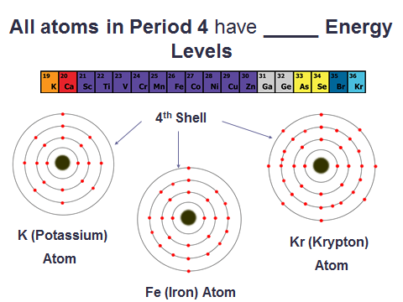

Every atom in a period has the same: _________________

Number each group (use group name when applicable)

- Write the group e⁻ configuration
(use quantum letter n pg 160 table 4)
- Draw the general electron dot diagrams (pg 184 table 10)
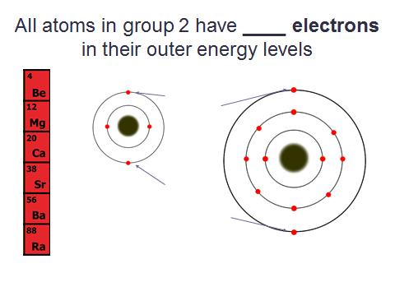
Every atom in a
group has the
same: _____________
Valence e⁻
Gain/lose e⁻
charge

