Name: ____________________________ Block: _______

Potential Energy Diagrams, Thermochemical Equations, &Thermochemistry Dimensional Analysis

- Use the following Potential Energy Diagram to the right for questions a-h
- Is this reaction endothermic / exothermic?
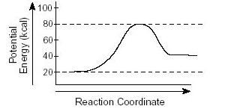
- How much stored P.E. do the reactants have? _______
- How much stored P.E. do the products have? _________
- How much activation energy, E_{a}, is needed for this reaction? ____________
- To get from the reactants to the products, energy had to be added / removed. How much? _________
- How much P.E. must be added to the reactants to form the activated complex? ____________
- What is the value of ΔH or ΔH_{rxn}? ____________
- Is ΔH_{rxn} positive or negative? _____________

- Use the Potential Energy Diagram to the left for questions a-f
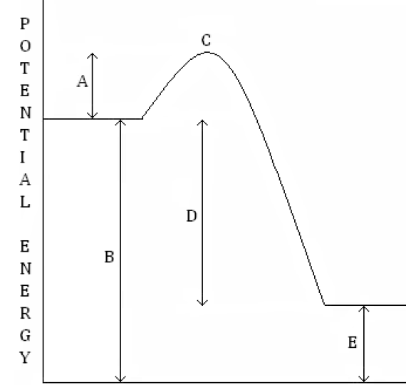
- Is this reaction endothermic / exothermic?
- Which line segment represents the stored P.E. of the reactants? ____
- Which line segment represents the stored P.E. of the products? _____
- Which line segment represents the activation energy, E_{a}, that is needed for this reaction? ________
- Which line segment represents the ΔH (change in P.E.) for the reaction? _______ Is it positive / negative? _________
- Which line segment represents the P.E. of the activated complex? ____

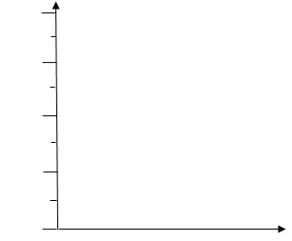
- To the right, draw a reaction path diagram with the following criteria:
  - an exothermic reaction
  - reactants have 250kJ of potential energy stored in their bonds
  - 100kJ of activation energy required
  - products have 50kJ of potential energy stored in their bonds
  - Scale and label the y axis for kJ of potential energy.

  - Calculate $∆H$ = _____________

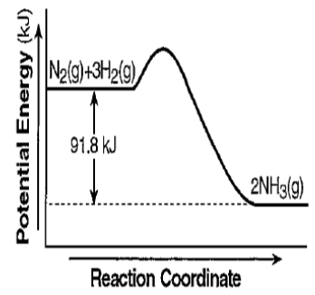
- Write a thermochemical equation based off the information found in the energy path diagram below.

- Write the following reactions with the change in enthalpy as a reactant or product.
Fe + CO₂ Fe₂O₃ + CO ΔH = + 26.3 kJ

- In the thermochemical equations below, the energy has been written on the reactants side or the products side. Write the energy as a ΔH value with the correct sign for the reaction below.
CrO₃ + H₂O H₂CrO₄ + 5.4 kJ

- Compute the heat change for the production of 150 g iron (III) oxide in the following equation:
4FeO + O₂ 2Fe₂O₃ + 560kJ

- How many molecules (particles) of carbon dioxide are produced by the decomposition of Nitroglycerin?
4C₃H₅(NO₃)₃ → 6N₂ + O₂ + 12CO₂ + 10H₂O + 1804 kJ

