Unit 6: Mixtures Chapter 12 & 13
Draw the dissolution process, include solute and solvent

Parts of a Mixture: (pg 402)
- Solute:
- Solvent:
Electrolytes (Pg 406 & 442)
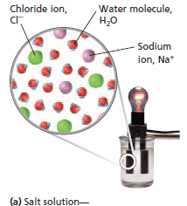
- Label each being an electrolyte or as a nonelectrolyte
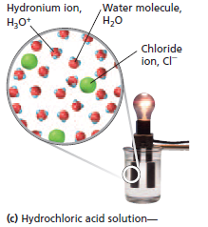
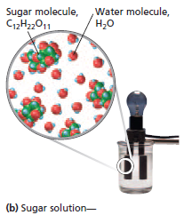

- Strong electrolyte:
- Weak electrolyte:
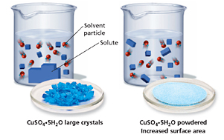
Factors that affect rate of Dissolution (Pg 407)
- Where does dissolution occur?

- Label the beakers below as small or large surface area and note if the size of particles are big or small.

- _____________ the surface area of the solute = ___________ particle size of the solute =___________ contact of the solute to the solvent = ____________ rate of dissolution.
- Increasing agitation = increasing _____________ or ____________ helps to disperse the solute particles = ___________ contact of the solute to the solvent = _____________ rate of dissolution.
- Higher temperature = ________ frequency of collisions between solvent and solute = ______ energy = ______ rate of dissolution because there is ______ energy to separate the _________ and to _________ them in among the solvent molecules.
- However, in gases (pg 414) generally the ____________ temperature _______________ the solubilty of the gas in the liquid.
- How does pressure effect the rate of dissolution? Explain. (pg 413)

Solubility (pg 408-409)
- At a given temperature, there is a ____________ to the amount of solid solute that can be dissolved in a solvent.
- ______________ in the amount of that solid dissolves = ____________ in the concentration of dissolved molecules = _____________ collisions between solvent and solute.
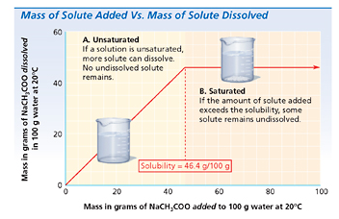
- A dynamic equilibrium is established between dissolution and _________________ when the amount of molecules that are crystallizing is the ________________ the amount that are going into solution.

This is the point in which….

- Saturated:
- Unsaturated:
- Supersaturated:
- How long will a supersaturated solution last?
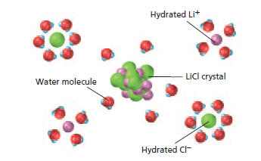
Solute-Solvent Interactions (pg 410-413)
- Describe the statement “likes dissolve likes”

- Describe what is going on in the picture

- miscible:
- immiscible:
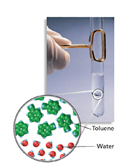
- Describe what is going on in the pictures (Pg 412)
