**Radiation**

To Fear or Not to Fear?

The term radiation strikes fear into the hearts of most people. Yet, all of us are constantly exposed to radiation, and for the most part we suffer few adverse effects. In fact, some forms of radiation are critical to life. Without light and heat from the Sun, both forms of electromagnetic radiation, Earth would be a dark, cold, and lifeless place.   
  
Radiation may be in the form of electromagnetic waves such as light and gamma rays, or particles such as neutrons, protons, and electrons. Regardless of its form, all radiation carries energy and affects matter by transferring its energy to the particles in matter. This causes the atoms and molecules of the affected material to vibrate or to undergo a change in their chemical arrangement or internal state or structure.   
  
The energy from radiation sometimes increases molecular movement slightly, causing a gentle warming or a change in state, such as from solid to liquid. An example of this type of change is the melting of snow in the sunlight. In other cases, radiation's energy is powerful enough to knock the electrons out of atoms or molecules, transforming them into negatively or positively charged ions. Radiation at such a high energy level is called **ionizing radiation**.   
  
Scientists call substances that spontaneously give off radiation in the form of waves or particles **radioactive**. Instability in the atomic nuclei of radioactive substances causes them to cast off electromagnetic rays or subatomic particles. This process, called **radioactive decay**, may result in a more stable form of the same element or in a different element altogether. Often, the new elements that result from radioactive decay are also unstable and undergo further decay.

**What is radioactivity?**

Atoms with unstable nuclei are constantly changing as a result of the imbalance of energy within the nucleus. When the nucleus loses a neutron, it gives off energy and is said to be **radioactive**. **Radioactivity**is the release of energy and matter that results from changes in the nucleus of an atom.

**What is a radioisotope?**

Recall that isotopes are variants of an element that, while all having the same number of protons, have differing numbers of neutrons. These variants are called isotopes. Because the like charges of the protons repel each other, there are always forces trying to push the atom nucleus apart. The nucleus is held together by something called the **binding energy**.

The neutron-proton ratio determines the stability of a nucleus. In most cases, elements like to have an equal number of protons and neutrons because this makes them the most stable. Stable atoms have a binding energy that is strong enough to hold the protons and neutrons together. Even if an atom has an additional neutron or two it may remain stable. However, an additional neutron or two may upset the binding energy and cause the atom to become **unstable**. In an unstable atom, the nucleus changes by giving off a neutron to get back to a balanced state. As the unstable nucleus changes, it gives off radiation and is said to be radioactive. Radioactive isotopes are often called **radioisotopes**.

All elements with atomic numbers greater than 83 are radioisotopes meaning that these elements have unstable nuclei and are radioactive. Elements with atomic numbers of 83 and less, have isotopes (stable nucleus) and most have at least one radioisotope (unstable nucleus). As a radioisotope tries to stabilize, it may transform into a new element in a process called **transmutation**.

**What is radioactive decay?**

**Radioactive decay** is the spontaneous breakdown of an atomic nucleus resulting in the release of energy and matter from the nucleus. Remember that a radioisotope has unstable nuclei that does not have enough binding energy to hold the nucleus together. Radioisotopes would like to be stable isotopes so they are constantly changing to try and stabilize. In the process, they will release energy and matter from their nucleus and often transform into a new element. This process, called**transmutation**, is the change of one element into another as a result of changes within the nucleus. The radioactive decay and transmutation process will continue until a new element is formed that has a stable nucleus and is not radioactive. Transmutation can occur naturally or by artificial means.

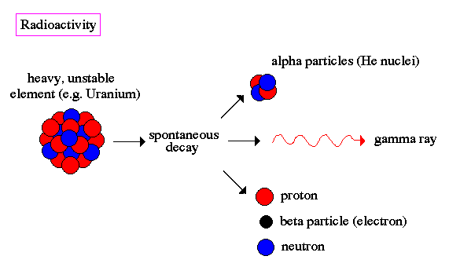

**What is released when a nucleus undergoes radioactive decay?**

Two main forms of radiation that can be released:

1. Particles (matter) – protons, neutrons, electrons
2. Electromagnetic waves (photons) – energy in the form of gamma rays

Each nuclear radiation has a specific composition and penetrating power.

|  |  |  |  |  |
| --- | --- | --- | --- | --- |
|  | **Symbol** | **Composition** | **Penetration Power** | **Can Be Stopped By** |
| Alpha Particle | He or α | Helium nucleus | Low | Paper, skin |
| Beta Particle | e- or β | Electron | Low-medium | Heavy clothing, glass, plastic, light metals |
| Gamma Ray | γ | High energy photons (electromagnetic spectrum) | High | Lead or concrete |

**What is the difference between chemical reactions and nuclear reactions?**

**Nuclear reactions** can be described mathematically in much the same way as chemical reactions. We commonly express these reactions by equations, although there is a unique difference in the nature of the reactions. The principle difference between them lies in how the reaction occurs, specifically how the atom is affected. Chemical reactions involve an atom’s electrons while nuclear reactions involve the atom’s nucleus.

**Types of Nuclear Reactions**

Nuclear reactions involve changing the composition of the nucleus and the release of a lot of energy. There are two types of nuclear reactions:

1. **Fission** – a heavy nucleus splits into two lighter nuclei; used in nuclear power plants and nuclear bombs

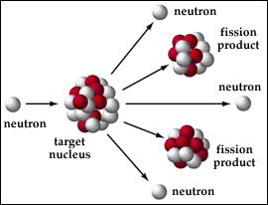

1. **Fusion** – two nuclei combine to make one heavier nucleus; occurs in the Sun and stars



**Writing a nuclear reaction equation**

In order to write an equation for a nuclear reaction, we will nuclear symbol notation. Recall that two numbers are attached to the symbol. The number at the upper right is the **mass number**, also known as the ‘A’ number. The 'A' number describes the atomic weight of the atom and identifies the number of protons and neutrons in the nucleus. The number at the lower left is the**atomic number**, or ‘Z’ number. The 'Z' number describes the number of protons in the nucleus and determines the type of atom.

* The symbol for Uranium-238 = Uranium Symbol

**This shows you that Uranium has a mass number of 238 and an atomic number of 92.**

**Symbols are also utilized to represent alpha and beta particles.**

* The symbol for an alpha particle = Alpha Particle
* The symbol for a beta particle is Beta Particle
* The chemical symbol for a neutron = Neutron

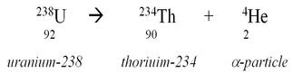Now that we know what these symbols represent, let's see how they can be applied to a nuclear equation. Uranium-238 is an isotope, which undergoes alpha decay to produce Thorium. This is expressed mathematically by the following equation:

Note that when the mass numbers on each side of the equation are added together that they are equal. The same principle is true for the atomic numbers, and it shows that none of the atomic particles have been lost. One way to check to see if you have written the proper nuclear equation is to make sure both sides of the equation have the same sum of mass numbers and same sum of atomic numbers.

|  |  |
| --- | --- |
| **Radioisotope** | **Half-life** |
| Polonium-215 | 0.0018 seconds |
| Bismuth-212 | 60.5 seconds |
| Sodium-24 | 15 hours |
| Iodine-131 | 8.07 days |
| Cobalt-60 | 5.26 years |
| Radium-226 | 1600 years |
| Uranium-238 | 4.5 billion years |

**Half-life – A measure of the rate of decay**

Each radioactive isotope has its own decay pattern. Not only does it decay by giving off energy and matter, but it also decays at a rate that is characteristic to itself. The rate at which a radioactive isotope decays is measured in half-life. The term **half-life** is defined as the time it takes for one-half of the atoms of a radioactive material to disintegrate. Half-lives for various radioisotopes can range from a few microseconds to billions of years. See the table below for a list of radioisotopes and each of unique their half-lives.

**How does the half-life affect an isotope?**

Let's look closely at how the half-life affects an isotope. Suppose you have 10 grams of Barium-139. It has a half-life of 86 minutes. After 86 minutes, half of the atoms in the sample would have decayed into another element, Lanthanum-139. Therefore, after one half-life, you would have 5 grams of Barium-139, and 5 grams of Lanthanum-139. After another 86 minutes, half of the 5 grams of Barium-139 would decay into Lanthanum-139; you would now have 2.5 grams of Barium-139 and 7.5 grams of Lanthanum-139.

**How is half-life information used in carbon dating?**

The half-lives of certain types of radioisotopes are very useful to know. They allow us to determine the ages of very old artifacts. Scientists can use the half-life of Carbon-14 to determine the approximate age of organic objects less than 40,000 years old. By determining how much of the carbon-14 has transmutated, scientist can calculate and estimate the age of a substance. This technique is known as **Carbon dating**. Isotopes with longer half-lives such as Uranium-238 can be used to date even older objects.

Sources: <https://www.nde-ed.org/EducationResources/HighSchool/Radiography/introxrays.htm>

<http://www.pbslearningmedia.org/resource/phy03.sci.phys.matter.everyday/everyday-radiation/>