Name___________________________________ Date_____________ Block ______ Reactions Study Guide

Part 1: Balancing, Determining if a Reaction is Endothermic or Endothermic, Determining Type of Reaction
Balance the reaction, determine if endothermic or exothermic, and determine the type of reaction. (Hint: If you see a polyatomic ion like (NO₃) on both sides of the arrow () you can balance it as a whole unit)
Video Help: Types of rxn Types of rxn with predicting Balancing Khan Balancing Endo/Exo w/ diagrams

Rxn Type:_________ ______________
- ____Mg₃N_{2 (s)} + energy ____Mg _{(s)} + ____N₂ _{(g)} endo or exo
Rxn Type:_________ ______________
- ___K₂(CO₃) _{(aq)} + ___Ag(NO₃) _{(aq)} ___Ag₂(CO₃) _{(s)} + ___K(NO₃) _{(aq)} + energy endo or exo
- ____CH₄ _{(g)} + ____ O₂ _{(g)} ____CO_{2(g)} + ____H₂O _{(l)} + energy endo or exo
Rxn Type:_________ ______________
- ___Na(OH) _{(aq)} + ___ H₂(SO₄) _{(aq)} ___Na₂(SO₄) _{(aq)} + ___H(OH) _{(l)} + energy endo or exo
Rxn Type:_________ ______________
- ___Al _{(s)} + ____Cu(NO₃)_{2 (aq)} ____Cu _{(s)} + ____Al(NO₃)_{3 (aq)} + energy endo or exo
Rxn Type:_________ ______________
- ____ KClO₃ _{(s)} + energy ____ KCl _{(s)} + ____O₂ _{(g)} endo or exo
Rxn Type:_________ ______________
- ____ C₃H₈ _{(g)} + ____O₂ _{(g)} ____CO_{2(g)} + ____ H₂O _{(l)} + energy endo or exo
Rxn Type:_________ ______________
- ____K₂(SO₄) _{(aq)} + ___ Pb(OH)₂ _{(aq)} ___ Pb(SO₄) _{(s)} + ___K(OH) _{(aq)} + energy endo or exo
Rxn Type:_________ ______________
- ____ Li _{(s)} + ____Zn₃(PO₄)_{2 (aq)} ____Zn _{(s)} + ____Li₃(PO₄) _{(aq)} + energy endo or exo
Rxn Type:_________ ______________
- ____Mg(NO₃)_{2 (s)} + energy ____ MgO _{(s)} + ____NO_{2 (g)} + _____ O_{2(g)} endo or exo
Rxn Type:_________ ______________

Part 2: Describe
- What are indications of a chemical reaction?

- How can a chemical reaction be made to occur faster? Explain.

Soluble/Insoluble/net ionic

Part 3: Determine if the following are soluble or insoluble and if a precipitate or an aqueous solution forms.
- CaCO₃
- Potassium iodide
- NH₄OH
- PbSO₄
- Silver chloride
- KC₂H₃O₂

Part 4: Determine Type, Predict Products, Balance & If double replacement determine the net ionic reaction

- ___FeCl₃ (aq) + ___Hg(NO₃)₂ (aq)
- __As + __BaSO₄
- ___Zn + ___HCl
22. ____C₂H₅OH + ____O₂
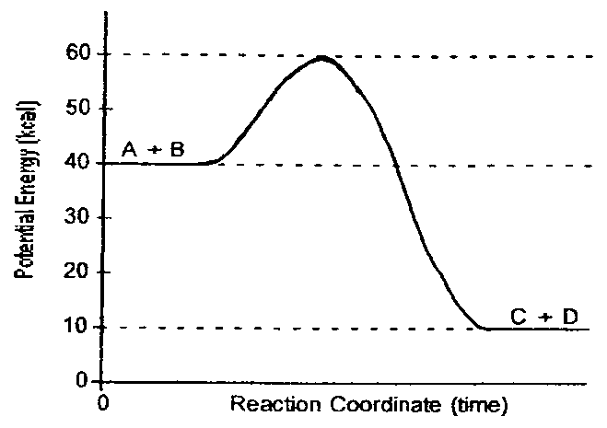
Part 5: Potential energy path diagrams
Figure 1

Questions 23-25 refer to Figure 1
23. Is the reaction endothermic or exothermic?
24. How much activation energy is needed?
25. What is the Δ H_{rxn}?
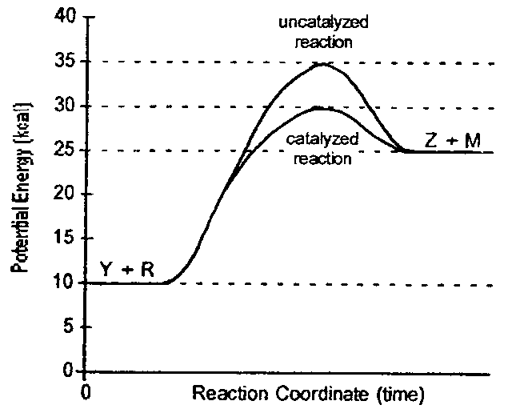
Questions 26-32 refer to Figure 2
Figure 2
26. Is the reaction endothermic or exothermic?
27. What is the value of the activation energy of the uncatalyzed reaction?
28. What is the value of the activation energy of the catalyzed reaction?
29. What is the ΔH_{rxn} for the uncatalyzed reaction?
30. What is the ΔH_{rxn} for the catalyzed reaction?
31. How does ΔH for the catalyzed compare to ΔH for the uncatalyzed reaction?
32. What is the purpose of adding a catalyst?
Figure 3
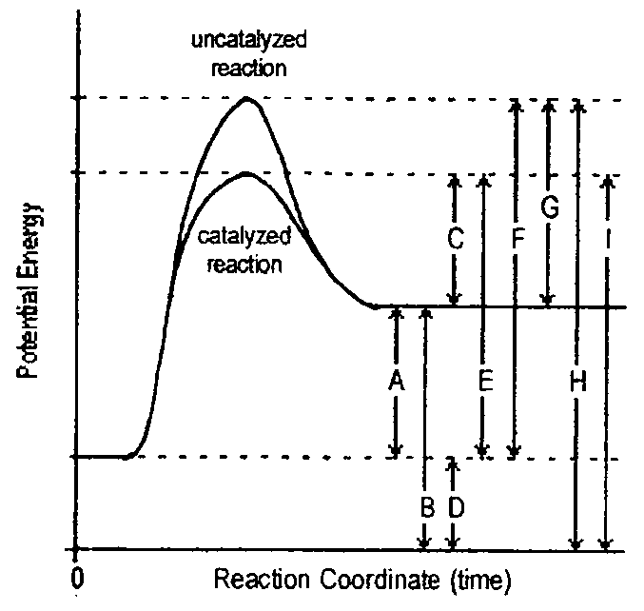
Questions 33-39 refer to Figure 3.
33. Potential energy of the reactants
34. Potential energy of the products
35. Activation energy of the catalyzed reaction.
35. Activation energy of the uncatalyzed reaction
39. Heat of reaction (ΔH).

Part 6: Thermochemical equations
40. How many grams of nitrogen dioxide is produced with 513 kJ of heat is used in the following reaction:
2N₂O₅ + 110 kJ 4NO₂ + O₂

41. How much heat is released when 15.31 g of sulfur dioxide react in:
2 SO₂ + O₂ 2 SO₃ + 198 kJ

42. How many moles of phosphoric acid is produced when 1157 kJ of heat is used in the following reaction:
P₄O₁₀ + 6 H₂O 4H₃PO₄ + 424 kJ

