Part 2: Safety Equipment Functions
Directions: Match the name of each safety equipment with its function.
Safety Equipment:
- Fire Blanket B. Safety Shower C. Broken Glassware Box D. Goggles E. Baking Soda
F. Eyewash Station G. Fume Hood H. Spill Control Pads I. Fire Extinguisher J. Gas Cut Off
Letter | Function
 | 1. Protects the eyes from chemicals and debris. Must be worn during all labs.
 | 2. Turns off the flow of gas in the classroom. This causes all Bunsen burners to be turned off. Only used in an emergency.
 | 3. Dispenses a large volume of water to wash chemical spills from the body. Activated by pulling the triangular handle.
 | 4. Used to put out a fire.
 | 5. Used to neutralize an acid spill.
 | 6. Used to flush chemicals from the eyes.
 | 7. A disposal container for broken glass.
 | 8. Used to absorb a chemical spill.
 | 9. A sheet of fire resistant material used to smoother small fires.
 | 10. An enclosed area that removes unwanted or toxic vapors within the area.

Part 3: Answer the questions below:
- List all precautions that should be taken with clothing worn in the lab.

- In what cases might you be told to sit out of a lab?

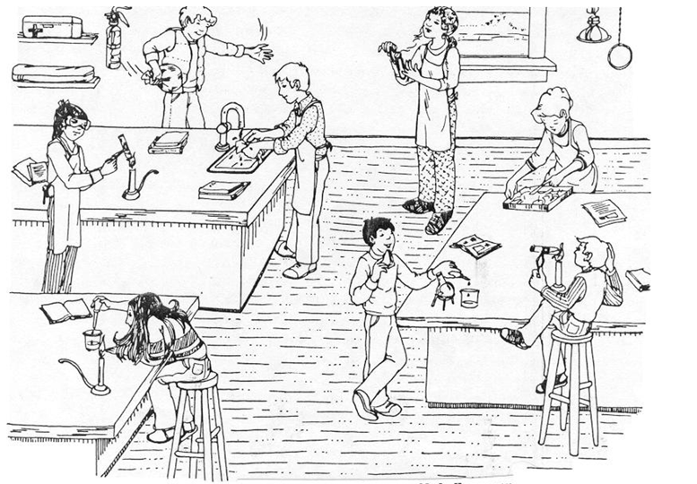
Part 4: Find all the things wrong with the picture below.

Name: ____________________________________________________ Room #:_____ Classroom Scavenger Hunt
Part 1: Lab Safety Map
Directions: Locate and label with the appropriate letter the location of the following safety equipment

- Eye Wash
- Safety Shower
- Fire Extinguisher
- Goggles
- Gas Cut Off
- Fume Hood
- First Aid Kit
- Spill Control Pads
- Baking Soda
- Fire Blanket
- Electrical Cut Off
- Glass Disposal
- Broom & Dust Pan

Window

Window
Teacher Desk
Door
Prep Room Door

Lab Stations
Lab Stations
Prep Room

