Energy in Reactions
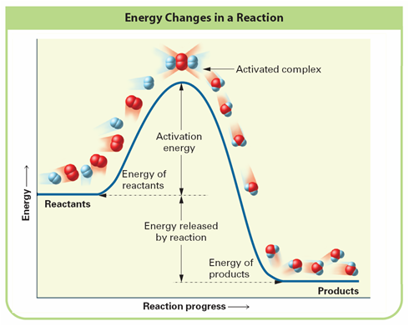
Energy Path Diagram:

Activation energy (E_{a}) | Energy needed to __________reactant ___________ thus ____________the rxn
Activated complex? (Ea’) | “top of the hill” where the reactant atoms_______________due to the  ______________.
Enthalpy | _____________ involved in a ______________ or ______________change
ΔH_{rxn} represents | Energy __________________ as _________________ during a reaction :  _______________ – ______________

 | Endothermic | Exothermic
Sign
Descriptive Words
Drawing | system | system
 | Endothermic | Exothermic
Chemical Reaction Placement | A + B  Or  A + B C ΔH= | A + B  Or  A + B C ΔH=
Rxn Path Diagram | 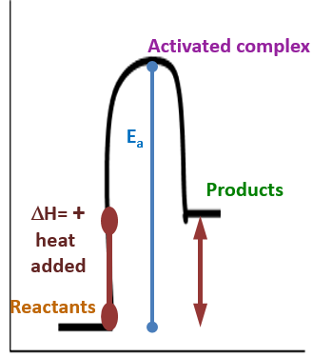

Examples
Process | Exo or  Endo | Explanation
Si + 2Cl₂ → SiCl₄ ΔH = -657 kJ
An ice cube melts after being left out on the table.
2HgO → 2Hg + O₂ ΔH = + 181 kJ
Burning a match.
2 N₂O₅ (g) + 110 kJ 4NO₂(g) + O₂(g)

Making ice cubes.
P₄O₁₀(g) + 6H₂O(l) 4 H₃PO₄(aq) + 424 kJ
A puddle of water evaporates.
2H₂O₂(l) 2H₂O(l) + O₂(g) + 200kJ
Gas molecules condensing on the side of a glass of iced tea.

