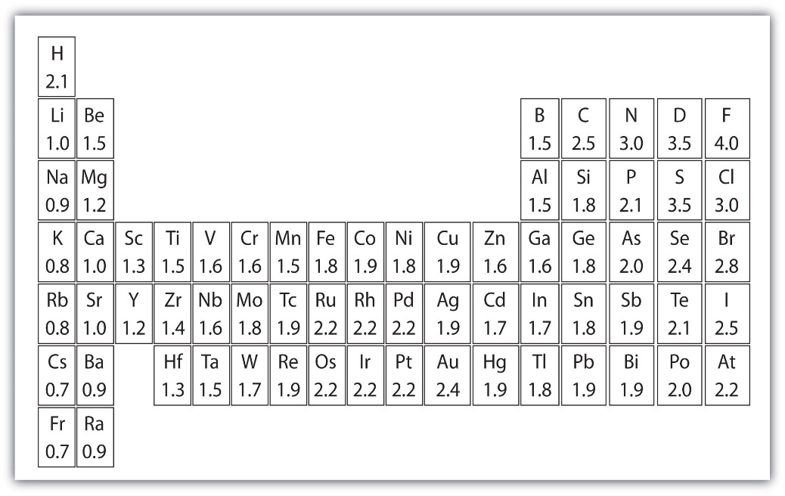

**Electronegativity Values**

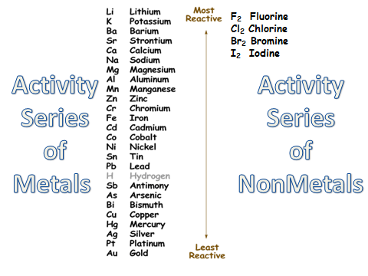

**Solubility Table:**

1. All compounds of **Group 1 and ammonium soluble**.

* All **nitrates, acetates & chlorates soluble**
* All **halides soluble*:*** *except those of silver, mercury (I) & lead.*
* All **sulfates soluble:** *except calcium, barium, strontium, lead, & mercury.*
* All **carbonates, chromates, sulfides, hydroxides, oxides, phosphates, & silicates insoluble**: *except for group 1 and ammonium (rule 1)*

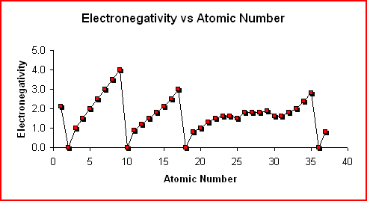

F

H

Cl

Br

He

Ne

15 Ar

Kr

Rb

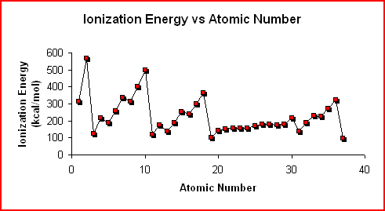

He

Ne

Ar

Kr

H

Li

Na

K

Rb