Periodic Trends
Can the properties of an element be predicted using a periodic table?
Why?

The periodic table is often considered to be the “best friend” of chemists and chemistry students alike. It includes information about atomic masses and element symbols, but it can also be used to make predictions about atomic size, electronegativity, ionization energies, bonding, solubility, and reactivity. In this activity you will look at a few periodic trends that can help you make those predictions. Like most trends, they are not perfect, but useful just the same.
- Recap from Coulombic Attraction going down a group:
  - The energy levels (increase/decrease/stay constant) going down a group.
  - As the number of energy levels increases, the distance between the nucleus and valence electrons _____________________________________________.
  - As the number of energy levels increases, the force of attraction between the nucleus and valence electrons ___________________________________.
- Now, consider the data in Model 1 on the following page.
  - Each element has three numbers listed under it. Which value represents the atomic radius?

  - What are the units for the atomic radius?
  - Write a complete sentence to convey your understanding of atomic radius. Note: You many not use the word “radius” in your definition.

- In general, looking at model 1, the atomic radius _____________ going down a group. Support your answer by using an example.

- Using your knowledge of Coulombic attraction and the structure of the atom, explain the trend in atomic radius that you identified in Question 3. (Hint: You should discuss either a change in distance between the nucleus and valence electrons or a change in the number of protons in the nucleus.)

- Recap from Coulombic Attraction going across a period:
  - The energy levels (increase/decrease/stay constant) going across a period.
  - The atomic number (increase/decrease/stay constant) going across a period.
  - The number of protons (increase/decrease/stay constant) going across a period.
  - While moving across a period, the force of attraction between the nucleus and valence electrons _______________________ because there are _____________ protons.
- In general, looking at model 1, the atomic radius _____________ going across a period (left to right). Support your answer by using an example.

- Using your knowledge of Coulombic attraction and the structure of the atom, explain the trend in atomic radius that you identified in Question 4. (Hint: You should discuss either a change in distance between the nucleus and valence electrons or a change in the number of protons in the nucleus.)

- In each pair, determine which element has a bigger atomic radius. Explain why.
  - Calcium or Bromine
  - Germanium or Lead
  - Oxygen or Neon
  - Magnesium or Barium

Model 1 – Main Group Elements
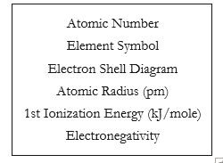
Note: The transition elements and f-block elements have been removed from the periodic table here to ease the analysis of the trends.

1  H |  |  |  |  |  |  | 2  He
37 pm |  |  |  |  |  |  | 31 pm
1312 kJ/mole |  |  |  |  |  |  | 2372 kJ/mole
2.1 |  |  |  |  |  |  | N/A
3  Li | 4  Be | 5 B | 6  C | 7  N | 8  O | 9  F | 10 Ne
152 pm | 112 pm | 83 pm | 77 pm | 71 pm | 66 pm | 71 pm | 70 pm
520 kJ/mole | 900 kJ/mole | 801 kJ/mole | 1086 kJ/mole | 1402 kJ/mole | 1314 kJ/mole | 1681 kJ/mole | 2081 kJ/mole
1.0 | 1.5 | 2.0 | 2.5 | 3.0 | 3.5 | 4.0 | N/A
11 Na  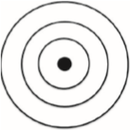 | 12  Mg  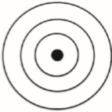 | 13 Al | 14  Si | 15 P | 16 S | 17 Cl | 18 Ar
186 pm | 160 pm | 143 pm | 117 pm | 115 pm | 104 pm | 99 pm | 98 pm
496 kJ/mole | 738 kJ/mole | 578 kJ/mole | 786 kJ/mole | 1011 kJ/mole | 1000 kJ/mole | 1251 kJ/mole | 1521 kJ/mole
0.9 | 1.2 | 1.5 | 1.8 | 2.1 | 2.5 | 3.0 | N/A
19  K  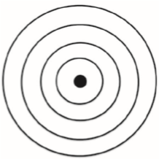 | 20  Ca  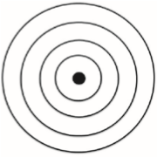 | 31 Ga  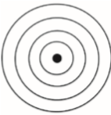 | 32 Ge  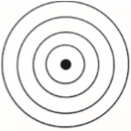 | 33 As  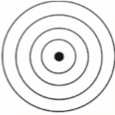 | 34 Se  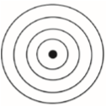 | 35 Br  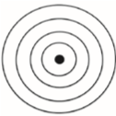 | 36  Kr  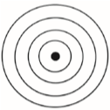
227 pm | 197 pm | 122 pm | 123 pm | 125 pm | 117 pm | 114 pm | 112 pm
404 kJ/mole | 550 kJ/mole | 558 kJ/mole | 709 kJ/mole | 834 kJ/mole | 869 kJ/mole | 1008 kJ/mole | 1170 kJ/mole
0.8 | 1.0 | 1.7 | 1.8 | 1.9 | 2.1 | 2.5 | N/A
- Locate the numbers in Model 1 that represent the ionization energy. The ionization energy is the amount of energy needed to remove an electron from an atom.
  - Using your knowledge of Coulombic attraction, explain why ionization—removing an electron from an atom—takes energy.

  - Which takes more energy, removing an electron from an atom where the nucleus has a tight hold on its electrons, or a weak hold on its electrons? Explain.

- In general, looking at model 1, the ionization energy _____________ going down a group. Support your answer by using an example.

- Using your knowledge of Coulombic attraction and the structure of the atom, explain the trend in ionization energy that you identified in Question 9.

- In general, looking at model 1, the ionization energy _____________ going across a period (left to right). Support your answer by using an example.

- Using your knowledge of Coulombic attraction and the structure of the atom, explain the trend in ionization energy that you identified in Question 11.

- Smaller atom = (stronger/weaker) the attraction between the nucleus and valence electron = (harder/easier) it is to remove an electron = (more/less) energy needed to remove electron = (higher/lower) ionization energy.

- Atoms with loosely held electrons are usually classified as metals. They will exhibit high conductivity, ductility, and malleability because of their atomic structure. Would you expect metals to have high ionization energies or low ionization energies?

- In each pair, determine which element has a higher ionization energy. Explain why.
  - Calcium or Bromine
  - Germanium or Lead
  - Oxygen or Neon
  - Magnesium or Barium

Read This!

Electronegativity is a measure of the ability of an atom’s nucleus to attract electrons from a different atom within a bond. A higher electronegativity value correlates to a stronger pull on the electrons in a bond. This value is only theoretical. It cannot be directly measured in the lab.

- Using the definition stated in the Read This! box above, select the best visual representation for electronegativity. Explain your reasoning.
A B C D
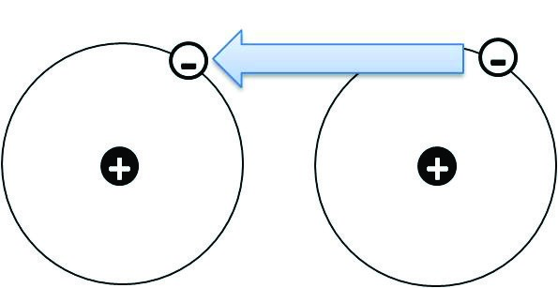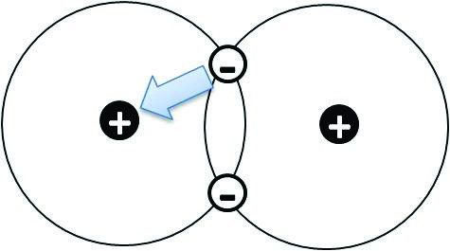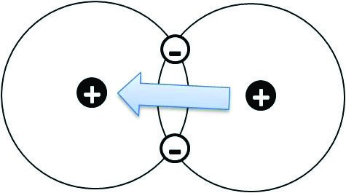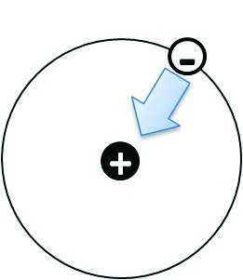

- Locate the electronegativity values in Model 1.
    - What is the trend in electronegativity going down a group in Model 1?
    - Explain the existence of the trend described in part a in terms of atomic structure and Coulombic attraction.
    - What is the trend in electronegativity going across a period in Model 1?
    - Explain the existence of the trend described in part c in terms of atomic structure and Coulombic attraction.
- In each pair, determine which element has a higher electronegativity. Explain why.
  - Calcium or Bromine
  - Germanium or Lead
  - Oxygen or Neon
  - Magnesium or Barium

- On the diagrams below summarize each of the three trends discussed in this activity. Write either:
- small atomic radius or big atomic radius
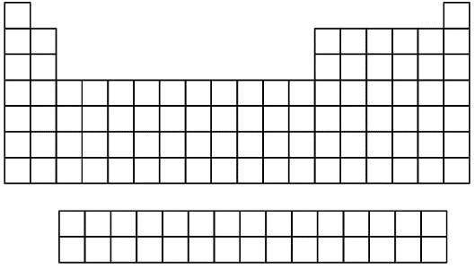
- high ionization energy or low ionization energy
- high electronegativity or low electronegativity

