Unit 3 Study Guide Name:_______________________________________
Chapters 3 & 4 Test Date:_____________________Block:__________
- Complete the chart below on the subatomic particles:
 | charge | relative  mass | location | importance
proton
electron
neutron
- Use Figure 2.1 to answer the following questions.

  - How many protons does this atom have?
  - How many electrons does this atom have?
  - What is this atom’s mass number?
  - What is this atom’s charge?
  - What element does this atom represent?
Figure 2.1
16
S
32.07
- Use Figure 2.2 to answer the following questions.
  - Which number represents the atomic number?
Figure 2.2
  - Which number represents the atomic mass?
  - The first letter in a nuclear symbol is always ______.
- How do you determine how many protons are in a given element?

- What is the formula for mass number?

- Complete the chart below: assume all neutral atoms
 | Nuclear Symbol | Name | Atomic  # | Mass  # | # Protons | # Neutrons | # Electrons
a |  |  | 6 | 12
b |  |  |  | 9 | 4
c |  |  |  |  |  | 10 | 11
d |  |  |  | 34 | 17
e |  |  |  | 13 |  | 6

- Complete the chart below for the following charged atoms (ions).
 | Nuclear Symbol | Element | # Protons | # Electrons
a | Na⁺ | Sodium
b | F⁻ | Fluorine
c | S²⁻
d |  |  | 30 | 28
e |  |  | 8 | 10
- Rewrite the following isotopes in nuclear symbol notation.

  - Iron-55
  - Carbon-12

- What are the three steps in calculating the average atomic mass of an element?

- Calculate its average atomic mass.
Symbol Notation | Mass of Isotope | Percent  Abundance
$${}_{24}^{50}{Cr}$$ | 49.9460442 amu | 4.31%
$${}_{24}^{52}{Cr}$$ | 51.9405075 amu | 83.76%
$${}_{24}^{53}{Cr}$$ | 52.9406494 amu | 9.55%
$${}_{24}^{54}{Cr}$$ | 53.9388804 amu | 2.38%

He  Is it stable? | Orbital Diagram
 | Electron Configuration
B  Is it stable? | Orbital Diagram
 | Electron Configuration
Ar  Is it stable? | Orbital Diagram
 | Electron Configuration
Ni  Is it stable? | Orbital Diagram
 | Electron Configuration
- Complete the chart below.
- An element’s electron configuration is: 1s²2s²2p⁵
  - How many electrons does the atom have?
  - What element is this?
  - How many electrons does it have in energy level 1?____Energy level 2 ?____
- Match the atomic models with the appropriate scientist/name.
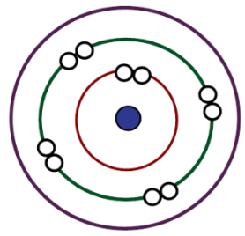
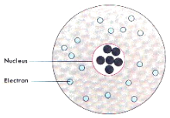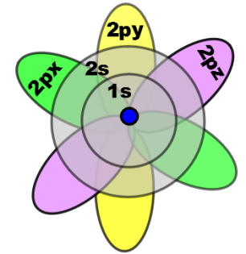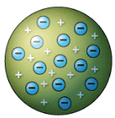
a._______________ b.________________ c.________________d._____________e.______________
I. Bohr II. Dalton III. Quantum IV. Rutherford V. Thomson
14. Put the atomic models above in correct chronological order in which they were developed.

- How many atoms of carbon are in 2.42 moles of carbon?

16. What is the mass, in grams, of 3.21 moles of strontium?

17. How many atoms of aluminum are in 4.62 grams of aluminum?

18. How many moles are in 5.86 x 10²⁴ atoms of platinum?

Review your warm-ups, notes, and quizzes.
Remember your homework from the unit, scientist foldable, scientist Cornell notes, & warm- up notebook is all due on Test Day!!!

