Unit 8: States of Matter
In this section, record questions, key words, main ideas, and reminders. Do after marking the text.
In the section below, mark the text by highlighting/underlining/ circling.

Kinetic energy is the movement of particles.
Temperature is a measure of average kinetic energy. Greater the kinetic energy the higher the temperature and the hotter it feels. Kelvin scale: K = 273 + °C

Kinetic Molecular Theory states that all particles of matter are always in motion! At absolute zero (OK) there is no movement of particles.
Solid particles are tightly packed in fixed positions that vibrate because they have more attractive forces.
Remember, electrostatic forces of attractions are the strongest and keep ionic compounds together. Whereas covalent molecules are attracted through intermolecular forces. The strongest intermolecular force is hydrogen bonding which is between hydrogen & nitrogen, oxygen, or fluorine. Dipole-Dipole force is between polar molecules. The weakest intermolecular force is london dispersion force which is between nonpolar molecules.
There are two types of solids: crystalline solids and amorphous solids. Crystalline solids have particles that are arranged in orderly, geometric, and repeating patterns. Whereas amorphous solid particles are “without shape” because the particles randomly arranged and have no repeating patterns. Examples of amorphous solids are glass, plastic, rubber.
Melting (fusion) is when the solid’s vibrations are strong enough to break the attractive forces.
Melting point = Freezing Point
Liquid particles are less ordered and more spread out than solid particles because the intermolecular forces are weaker. If the surface particles of the liquid have enough kinetic energy, they can overcome these attractive forces and escape into gas state.
In this section, write a summary of the notes on this page:
In this section, record questions, key words, main ideas, and reminders. Do after marking the text.

Vaporization is the process in which a liquid changes into a gas. There are two ways this can happen, evaporation or boiling.
Evaporation ≠ Boiling
Evaporation is the process of surface particles of a liquid become gas. The surface particles move faster are able to overcome the attractive forces that keep them in liquid state. Volatile liquids evaporate more easily because there is less attractive forces. Examples of volatile liquids are rubbing alcohol.
Boiling is when the internal vapor pressure is equivalent to the external vapor pressure. Increasing the temperature of the liquid, increases the internal (vapor) pressure of the liquid. The bubbles that appear are filled with gas of the liquid. If the external pressure is increased, then the internal pressure needs to increase which means the temperature of the liquid increases. This is how a pressure cooker works. On the other hand, if the external pressure is removed (a vacuum) then the internal pressure is reduced without changing the temperature.
Vaporization point = Condensation point
Pressure is a force or a “push” on an area and increases if the number of gas particle collisions increase. The atmosphere exerts pressure and is the sum of the individual gasses in the atmosphere pressures.
Standard Temperature & Pressure (STP) is 1.0 atm & 0°C
Sea level atmospheric pressure = 1.0 atm.
1 atmosphere (atm) = 760 mmHg = 101.3kPa
Gases have mass and take up space. Gas particles are far apart with no force of attraction and are in constant and random motion. Collisions between gas particles are elastic with no loss of kinetic energy and the energy is transferred from one particle to another. This causes pressure.
Liquids and gases both do not have fixed positions thus they both flow and will take the shape of their container. They are both considered to be fluids.
In this section, write a summary of the notes on this page:

Plasma: formed when a gas is heated to a temperature at which atoms lose their electrons. It is the most common state of matter in the universe. Examples of plasmas are lighting, solar winds, tails of comets, stars, earth’s ionosphere, wielding arcs, neon signs, and florescent lights.
In this section, record questions, key words, main ideas, and reminders. Do after marking the text.

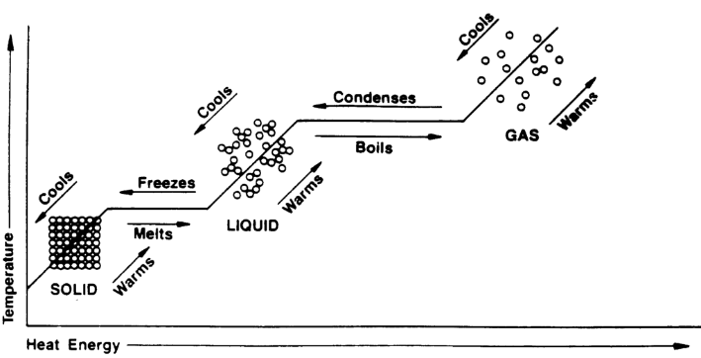
Phase Change Diagram

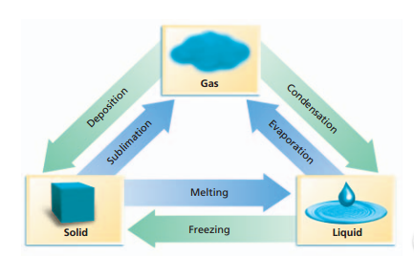
Phase Changes:

Dynamic Equilibrium is a condition in which two opposing changes occur at equal rates in a closed system. Example is the rate of evaporation = rate of condensation.

In this section, write a summary of the notes on this page:

Heat is the energy transfer between samples of matter because of their temperature difference. It moves from a higher temperature to a lower temperature until the temperature is the same for both samples of matter. Once each sample has the same temperature, there is no more energy being transferred which means no more heat.
In this section, record questions, key words, main ideas, and reminders. Do after marking the text.
Enthalpy of Fusion ΔH_{f} : amount of heat needed to change
1 mole of solid into a liquid.
Ex. If 300 kJ of heat is available, how much copper in grams can be melted? ΔH_{fCu} = 205 J/g

Enthalpy of Vaporization, ΔH_{v}: amount of heat needed to change 1 mole of a liquid into a gas.
Ex. How much heat is absorbed when 24.8 g of water is evaporated? ΔH_{vap H2O}= 40.65 J/mol

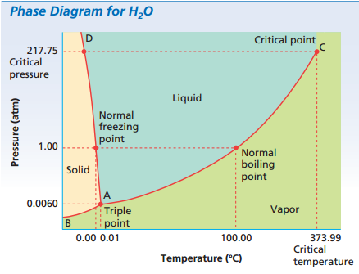
Phase Diagram :
Triple point: is the temp & pressure at which a solid, liquid, & gas coexist. AD Curve represents temp & pressure in which both a liquid & solid coexist. AC Curve represents temp & pressure in which both a liquid & vapor coexist.
In this section, write a summary of the notes on this page:

