Uncertainty in Measurement:
When reading an instrument…. Write all the #s you see + 1 more that you estimate
1.Determine the volume in each image below:
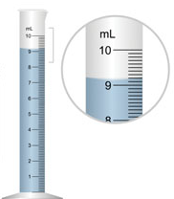 | 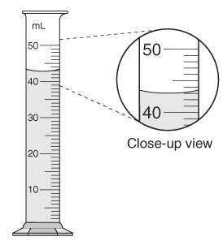 | 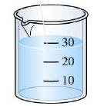 | 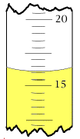
Name: ________________________________________________________ Block: _____________Sig Fig Practice
2. Determine the length in each centimeter rulers right: | 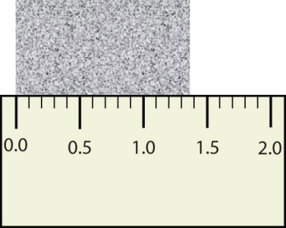 |  | 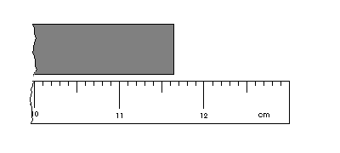
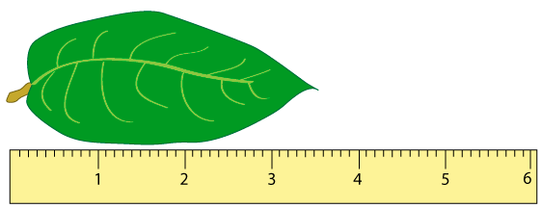
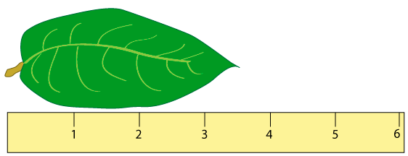
 | 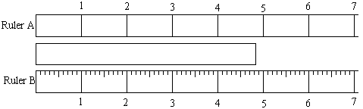
Sig Fig Rules
1. Count all non-zero # s: 1234 = 4 sig figs 100 = 1 sig figs
2. Count zeros that are in b/w non-zero #s: 708 = 3 sig figs 1008 = 4 sig figs
3. If # is less than 1, count all # after the first real # : 0.000987= 3 sig figs 0.009870 = 4 sig figs
do not count the zeros to the left of the first real #
4. If # is greater than zero & a decimal point is present, count all #s: 101.2 = 4 sig figs 1000.000= 7 sig figs
3. Determine the number of sig figs in each value
213 mg |  | 3001 dm |  | 81000 pg | 6.00 L
0.0021km |  | 0.420 g |  | 92.00 cm | 781 m

Adding & Subtracting Sig Fig Rules
5.00 cm
- 4.352 cm
0.648 cm =0.65 cm

0.648 cm =0.65 cm

- add or subtract the numbers
- keep all whole numbers
- round the decimal to the least number of decimal places
4. Determine the answer in terms of sig figs:
43.8316 sec  -29.5706 sec | 0.0677 mL  48.1 mL  +82.7655 mL |  |  | 27.34 km  6.90 km  +13.124 km |  | 2.8023 grams  -4.762 grams
334.540 grams  + 198.9916 grams | 248.01010 kilograms +84.097 kilograms |  |  | 0.0610 m  – 0.18 m |  | 50.2 miles  – 0.500 miles
0.04216 days  - 0.0004134 days | 23.1 hours  + 4.77 hours  + 125.39 hours  + 3.581 hours |  |  | 3.461728 grams  + 14.91 grams  + 0.980001 grams  + 5.2631 grams |  | 349.0 cm  + 1.10 cm  + 100. cm
Multiplying & Dividing Sig Fig Rules
6.7 cm x 1.1 cm= 7.37 cm² = 7.4 cm²
- multiply or divide # s
- count the TOTAL number of sig figs in each
- Round to the least # of TOTAL sig figs
5. Determine the answer in terms of sig figs:
2.61 x 10⁶ joules  0.0034 seconds | 24.1 miles  0.005 hour |  | 34 grams  10.1 mL |  |  | 252 meters  910 seconds
0.0222 mm x 0.7000mm x 8.702mm |  |  | 0.32cm x 14.50cm x 120cm |  |  | 1.80m x 25.3m
1010 cm x 3001cm x 216 cm |  |  | 6.450dm x 1.010dm |  |  | 0.61mm x 42.1mm
6. Determine the answer in terms of sig figs:
(320. - 22.7) x 3.8 |  | (1.80 x 3.4) + 32.00 |  |  | (1.80 x 25.3) + 32
(6.8 + 4.701)  (21.25 - 18) |  | (3.65 x 2.10)  (2.1134 x 42.1) |  |  | (14.86 + 13.7) x (65.346 - 4.10)  (43.888 - 32.888)
Average the following masses: 0.621g, 1.614g, 0.08456g, 0.4g

