Name:_____________________________________Date:____________Block:___
Radiation and Nuclear Discussion Questions
- Radiation can be in two main forms: electromagnetic waves (e.g. light and gamma rays) or particles (e.g. protons, neutrons, electrons). Each type of radiation has a specific amount of energy. Describe what is meant by the term ionizing radiation.

- What is radioactivity?

- The neutron-proton ratio determines the stability of a nucleus. Does a nucleus become more or less stable when its number of neutrons is larger than the number of protons?

- How does a radioisotope become stable? What happens to its nucleus?

- What are three types of nuclear radiation that can be released when a nucleus undergoes radioactive decay? Write the name and symbol of each.

- Which type of nuclear radiation is the highest in energy and has the most penetrating power? What type of substances are required to stop this high energy radiation?

- Describe the difference between a chemical reaction and nuclear reaction.

- Name and describe the difference between the two types of nuclear reactions.

- Fill-in the missing numbers on “Ra” in the following nuclear equation.

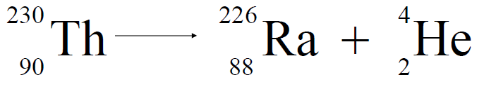

- The half-life of sodium-24 is 15 hours. How much of a 80. g sample of sodium-24 will remain after 45 hours?

