Orbital Diagram/Notation
Instead of drawing the shape(s), boxes are drawn to represent the shape
Electron Cloud Shape
s

p

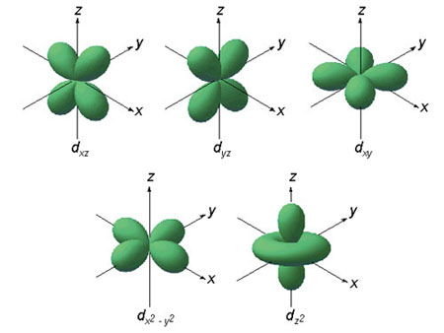

d

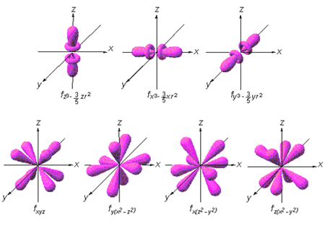

f

Na  Stable or  Unstable | Orbital  Diagram
 | Electron Configuration
C  Stable or  Unstable | Orbital Diagram
 | Electron Configuration

O  Stable or  Unstable | Orbital Diagram
 | Electron Configuration
Mg  Stable or  Unstable | Orbital Diagram
 | Electron Configuration
Ne  Stable or  Unstable | Orbital Diagram
 | Electron Configuration
Cl  Stable or  Unstable | Orbital Diagram
 | Electron Configuration
Fe  Stable or  Unstable | Orbital Diagram
 | Electron Configuration
*Cr  Stable or  Unstable | Orbital Diagram
 | Electron Configuration
*Cu  Stable or  Unstable | Orbital Diagram
 | Electron Configuration
Kr  Stable or  Unstable | Orbital Diagram
 | Electron Configuration
As  Stable or  Unstable | Orbital Diagram
 | Electron Configuration
Stable is a filled energy level (unreactive) or sub-level (still reacts)

