Name:_____________________________________Date:____________Block:___

Nuclear Homework

Part A: Write the complete nuclear equation.

- The following atoms all undergo alpha particle emission.

→ _________ + _________
→ _________ + _________
→ _________ + _________
→ _________ + _________

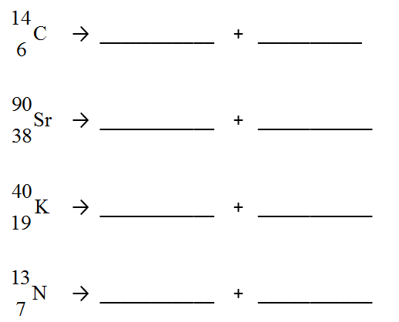
- The following atoms all undergo beta decay.

Part B: Half-Life
- Given that the half-life of carbon – 14 is 5730 years, consider a sample of fossilized wood that, when alive would have contained 24 g of carbon – 14. It now contains 1.5 g of carbon – 14. How old is the sample?

- A 64 g sample of germanium – 66 is left undisturbed for 12.5 hours. At the end of that period, only 2.0 g remain. What is the half-life of this material?

- 1.000 kg block of phosphorus – 32, which has a half-life of 14.3 days, is stored for 100.1 days. At the end of this period, how much phosphorus – 32 remains?

ANSWERS: #3) 22920 years #4) 2.5 hrs #5) 7.813 x 10⁻³ kg

