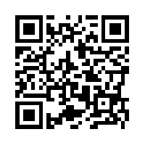**Mole Conversion Map**

http://newshamchem.weebly.com/the-mole.html

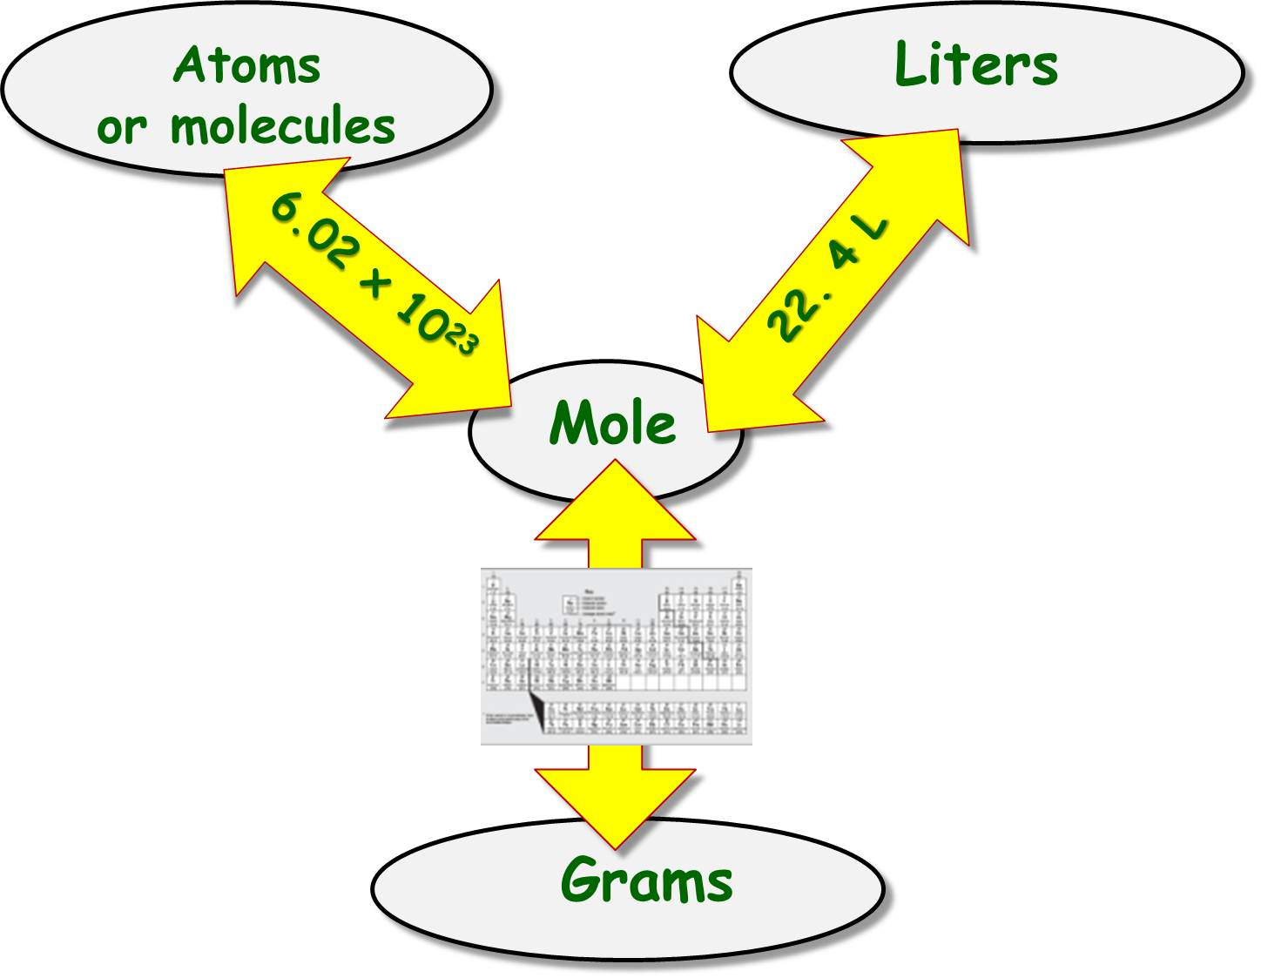

1. What is the mass, in grams, of 2.50 moles of methane, CH4?
2. How many moles of helium are in 16 grams of helium?
3. What is the volume, in liters, of 0.50 moles of ammonia, NH3?
4. How many moles of propane, C3H8, are in 67.2 liters of propane?
5. A sample of carbon contains 9 x 1023 atoms of carbon. How many moles of carbon are in the sample?
6. How many molecules of ethane, C2H6, are in 4 moles of ethane?
7. What is the mass, in grams, of 1.5 x 1023 molecules of methane, CH4?
8. What volume, in liters, is occupied by 15 grams of ethane, C2H6?

ANSWERS:

1. 40.1 g CH4 3) 11 L NH3 5) 1 mol C 7) 4.0 g CH4
2. 4.0 mol He 4) 3.00 L C3H8 6) 2 x 1024 molecules C2H6 8) 11 L C2H6