Model (Picture) with Description
Evolution of the Atom
Democritus  Model of Atom | Democritus was a philosopher in 400 B.C. (not a scientist) that stated :  Atoms are indivisible particles
Dalton  Model of Atom | 1808 The First Atomic Theory (experimented & concluded)  - All matter is composed of extremely small particles called atoms.  - Atoms cannot be subdivided, created, or destroyed.  - Atoms of the same element are identical; whereas, different element’s atoms are different from each other in size, mass, & other properties.  - Atoms of different elements combine in whole-number ratios to form compounds.  - Chemical reactions are when atoms combined, separated, or rearranged.
Cathode ray experiment: | 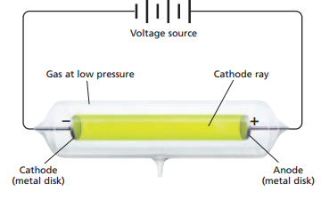  • The electric current (cathode rays) passed through gases in a glass tube.  • Cathode rays were repelled from the negative (– ) cathode and attracted to the positive (+) anode.  Thomson in 1897 concluded that:  1. That there was something smaller than an atom  2. Cathode rays are composed of identical negatively charged particles, called electrons
Millikan | Millikan in 1909 measured the charge of an electron through the oil drop experiment.
Thomson  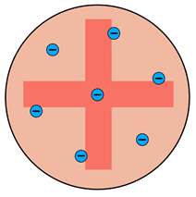  Model of the Atom | - Thomson called his model of the atom the plum pudding model.  - The negative electrons were spread randomly throughout the positive charge of the rest of the atom.  - Similar to seeds in a watermelon where the seeds are spread throughout.  ( Seeds = electrons flesh of fruit = positive mass)
Gold Foil Experiment  Performed in 1911 by:  Rutherford | 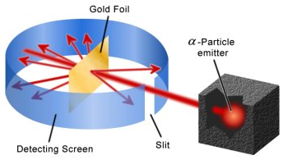  • Alpha particles have a positive charge.  • Positive Alpha particles were expected to pass through the atom without being deflected, most did.  • But some alpha particles were deflected, this was unexpected.
Rutherford’s  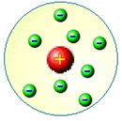  Model of Atom | deflection  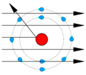  • A small number of positive alpha particles that were deflected proves that the nucleus is tiny and positive.  • Most of the particles passed through undisturbed proves the atom is mostly empty space.  Conclusion to the Goldfoil Experiment:  • Each atom contains a small, dense, positively charged nucleus surrounded by electrons
Bohr’s  Model of Atom ( 1913)  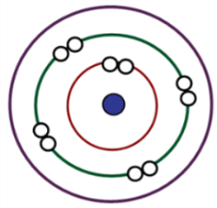  Planetary Model | 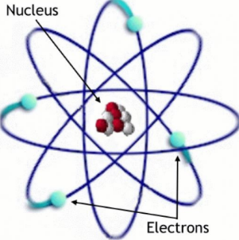  • Electrons move around the nucleus in set paths called orbits.  • Electron in its lowest energy is when it orbits closet to the nucleus.  • Energy of the electron is higher when it orbits farther away.  • Electron orbit is also called the atomic energy level.
Schrodinger’s  Quantum Mechanical  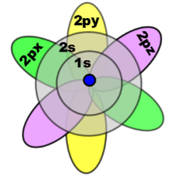  Model of Atom | •Schrodinger in 1926 concluded through math that electrons move in waves of specific energy.  • Electrons exist in certain regions called orbitals or electron cloud.  • Orbitals indicate the probable location of an electron and have different shapes and sizes.
Heisenberg’s  Uncertainty Principle (1927) | It’s impossible to know simultaneously both the location and the speed of an electron.

