Name:___________________________________ Date:_______ Block: ________
Metric Conversions, Measure Sig Figs, Count Sig Figs, & Round Sig Figs HW
- Convert each of the following quantities to the required unit.
  - 5.2 cm of magnesium to ______________________ mm of magnesium
  - 0.049 kg of sulfur to ____________________________ g of sulfur
  - 1.60 mL of ethanol to ___________________________ µL of ethanol
  - 0.020 kg of tin to _____________________________ mg of tin
  - 3 kL of saline solution to ______________________ L of saline solution
- A chemistry teacher needs to determine what quantity of sodium hydroxide to order. If each student will use 130 g and there are 150 students, how many kilograms of sodium hydroxide should the teacher order?
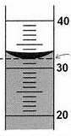

- Measure the following:
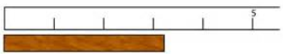

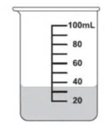
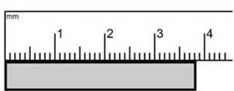

Name:___________________________________ Date:_______ Block: ________
Metric Conversions, Measure Sig Figs, Count Sig Figs, & Round Sig Figs HW
- Convert each of the following quantities to the required unit.
  - 5.2 cm of magnesium to ______________________ mm of magnesium
  - 0.049 kg of sulfur to ____________________________ g of sulfur
  - 1.60 mL of ethanol to ___________________________ µL of ethanol
  - 0.020 kg of tin to _____________________________ mg of tin
  - 3 kL of saline solution to ______________________ L of saline solution
- A chemistry teacher needs to determine what quantity of sodium hydroxide to order. If each student will use 130 g and there are 150 students, how many kilograms of sodium hydroxide should the teacher order?

- Measure the following:

- Determine the number of significant figures in the following measurements.

  - 640 cm³
  - 200.0 mL
  - 0.5200 g
  - 1.005 kg
  - 10 000 L
  - 20.900 cm
  - 0.000 000 56 g/L
  - 0.040 02 kg/m³
  - 790 001 cm²
  - 665.000 kg•m/s²

- Round the following quantities to the specified number of significant figures.
  - 5 487 129 m to three significant figures
  - 0.013 479 265 mL to six significant figures
  - 31 947.972 cm² to four significant figures
  - 192.6739 m² to five significant figures
  - 786.9164 cm to two significant figures
  - 389 277 600 J to six significant figures
  - 225 834.762 cm³ to seven significant figures

- Determine the number of significant figures in the following measurements.

  - 640 cm³
  - 200.0 mL
  - 0.5200 g
  - 1.005 kg
  - 10 000 L
  - 20.900 cm
  - 0.000 000 56 g/L
  - 0.040 02 kg/m³
  - 790 001 cm²
  - 665.000 kg•m/s²

- Round the following quantities to the specified number of significant figures.
  - 5 487 129 m to three significant figures
  - 0.013 479 265 mL to six significant figures
  - 31 947.972 cm² to four significant figures
  - 192.6739 m² to five significant figures
  - 786.9164 cm to two significant figures
  - 389 277 600 J to six significant figures
  - 225 834.762 cm³ to seven significant figures

