PHYSICAL VS. CHEMICAL CHANGE
 | PHYSICAL CHANGE | CHEMICAL CHANGE
Definition
Particle Representation
Indicators
Examples | 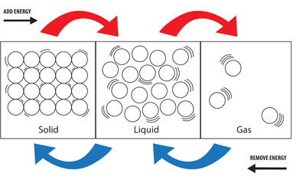  - Change in state of matter  - Change in shape  - Change in form  - Change in color  (e.g. painting) | Chemical Reactions
Separation Techniques | - Filtration  - Chromatography  - Magnetism  - Distillation  - Evaporation/Crystallization  - Density: Centrifuging and decanting | - Electrolysis

CANNOT be separated by
PHYSICAL means
CAN be separated by
PHYSICAL means
CHEMISTRY
THE STUDY OF MATTER
Anything with mass and volume

NEURTRONS

PROTONS

ELECTRONSS

MIXTURE
- Can be broken down into the pure substances/component of which it is made
- Each substance/component retains its chemical identity and properties
- Solute (the smaller quantity) is added to a solvent (greater quantity)
HETEROGENEOUS
- Non-uniform distribution
- Examples:
  - Trail mix
  - Italian dressing
  - Soil

HOMOGENEOUS
- Uniform
- Also known as SOLUTION
- Examples:
  - Alloys: Steel, Brass, Bronze, etc
  - Salt water
  - Atmospheric air

ELEMENT
- ONE type of atom
- Examples:
  - Sodium (Na)
  - Neon (Ne)

IONIC
- Made of IONIC bonds
- METAL bonds with NONMETAL through transfer of electrons
- Example: NaCl
NUCLEUS

ATOM

MOLECULAR
- Made of COVALENT bonds
- NONMETAL bonds with NONMETAL through sharing of electrons
- Example: H₂O

COMPOUND
- TWO or MORE DIFFERENT different types of atoms CHEMICALLY BONDED
- Examples:
  - Sodium chloride (NaCl)
  - Water (H₂O)

PURE SUBSTANCE
- Only way to separate into smaller units is to undergo a chemical reaction/change thus breaking chemical bonds.
- Has a specific chemical identity (formula)

