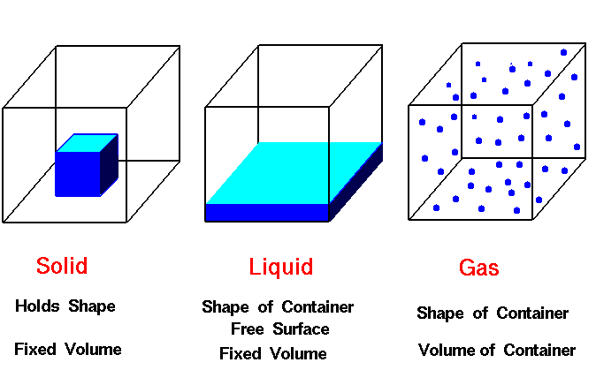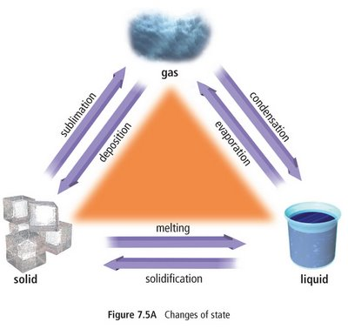

YES

***More than 1 atom***

***Is there a Metal present?***

Ionic

Covalent

***1 atom***

Nucleus

**e-**

**n0**

**p+**

Element

***Can it be broken down by a chemical reaction?***

NO

Italian dressing… “You have to shake/ stir” …granite

[**Separation Techniques**](../Separation%20Techniques.pptx)

Ex. Kool-aid, pure air, …

Solvent

Solute

*Solution*

Homogeneous

Heterogeneous

***Is the composition uniform?***

**YES****: Physical Change**

[**NO**](Chemical%20Changes.pptx)**: Chemical Change**

Substance

Mixtures

Chemistry

Matter

*Can it be physically separated?*

NO

YES

YES: 5 types of reactions

Compound

NO