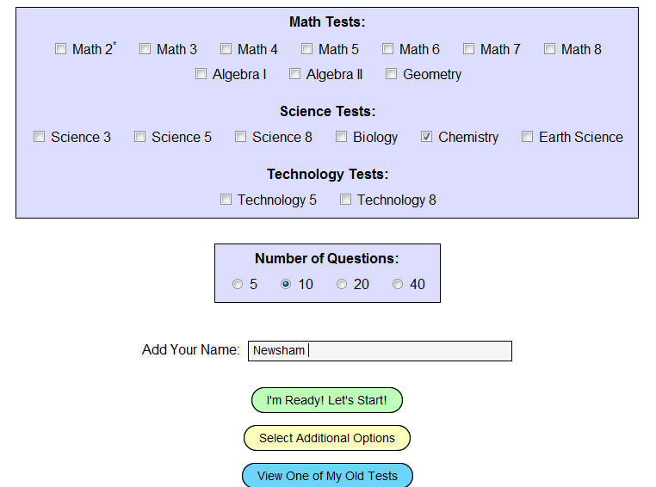
Jefferson Lab SOL Review Project
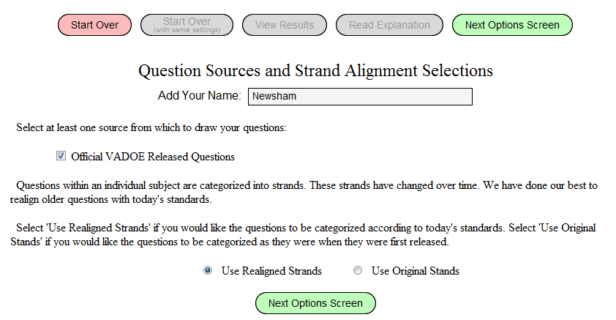
- http://education.jlab.org/solquiz/
- Choose CHEMISTRY & 10 Questions
- Select ADDITIONAL OPTIONS
- TYPE in your NAME & BLOCK
- Use REALIGNED STRANDS
- Click on Next Options Screen
- Click All Years
- You must do each strand that’s…..
10 questions of:
- Scientific Investigation
- Nomenclature, chemical formulas, & reactions
- Phases of Matter & Kinetic Molecular Theory
- Atomic Structure & Periodic Relationships
- Molar Relationships
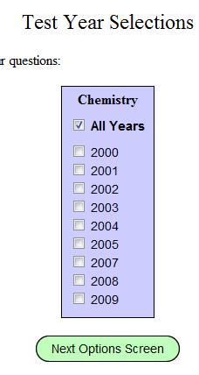
2 points turned in on time x 5 strands = 10 points
Sub
- Total: 10 questions x 5 strands= 50 questions = 50 points

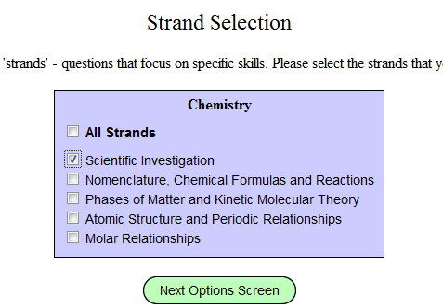
- Now you need to Choose 40 Questions
- Click I’m Ready! Let’s Start! (this will be mixed questions)

Asadfsdsafd 40 questions = 40 points

Grand Total: 100 points
- Scientific Investigation 11:59 Monday April 16th
- Nomenclature, chemical formulas, & reactions 11:59 Monday April 23rd
- Phases of Matter & Kinetic Molecular Theory 11:59 Monday April 30th
- Atomic Structure & Periodic Relationships 11:59 Monday May 7th
- Molar Relationships 11:59 Monday May 14th
- Mixed 40: turn in window: May 18th – 11:59 May 25th
-Optional mixed 40: turn in window: May 26th – 11:59 May 29th
Optional: An extra 40 question MIXED Question Set

Due Dates:
Turn over

10. Email Mrs. Newsham your results: laura.newsham@vbschools.com
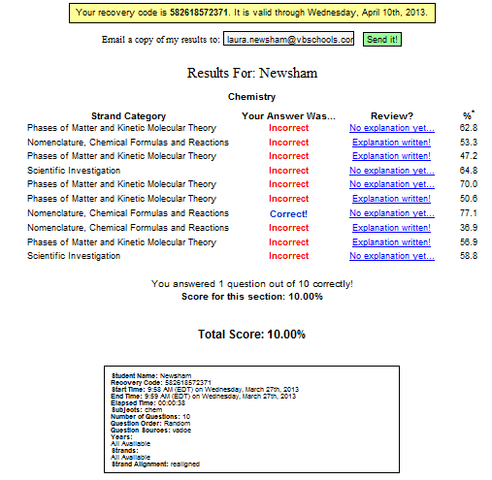

11. Email yourself and record the recovery code
