Electricity Supply

Nuclear energy is a reliable energy source, providing on-demand baseload electricity 24/7. The average nuclear energy facility is on line 90 percent of the time, generating on-demand electricity around the clock.
Nuclear energy is a secure electricity source that we can depend on as a reliable part of America’s electricity mix. It is not subject to changing weather or climate conditions, unpredictable fuel cost fluctuations or over-dependence on foreign suppliers.

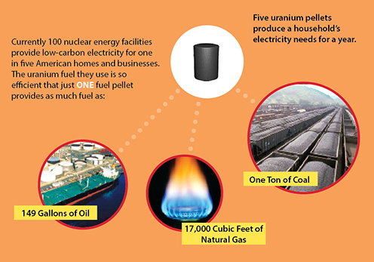
Nuclear energy facilities are able to produce electricity with low cost and stable prices using enriched uranium for fuel. One uranium fuel pellet—about the size of the tip of a pencil eraser—produces the same energy as 17,000 cubic feet of natural gas, 1,780 pounds of coal or 149 gallons of oil.

Nuclear Energy Most Efficient of All Electricity Sources
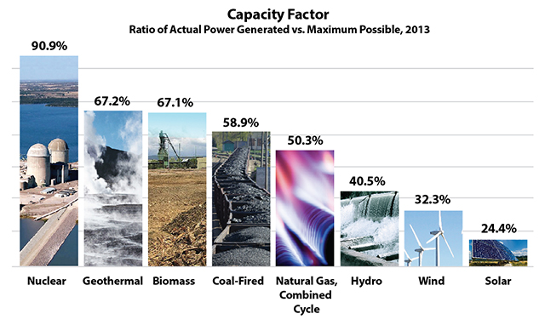
Nuclear energy facilities have the highest average capacity factor among all U.S. electricity sources. A facility’s “capacity factor” compares its actual energy production with how much it could produce at full operating power during the year. This is a crucial measure of a plant’s on-line performance, and it varies substantially by energy source. Nuclear power plants have low fuel costs and typically are operated around the clock.
Nuclear energy has tremendous price stability because fuel accounts for just 31 percent of production costs. Fuel costs are closer to 80 or 90 percent when electricity is produced by burning coal or natural gas. This makes electricity from fossil-fuel plants highly susceptible to fluctuations in coal and gas prices.

Clean Air Benefits
See how much each electricity source contributes to help the environment.
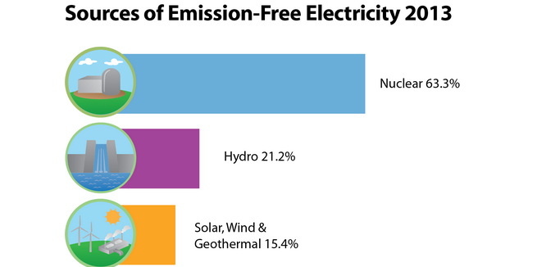
Nuclear energy is by far the largest clean-air energy source and the only one that can produce large amounts of electricity around the clock.

When Congress passed the Clean Air Act in 1970, nuclear energy supplied just 1 percent of America’s electricity. Today, 100 reactors in 31 states provide nearly 20 percent of America’s electrical power, replacing fossil-fueled plants that would have been built otherwise. Learn about nuclear facilities in your state.

Nuclear energy facilities help states and communities comply with air quality standards by generating electricity from fission—a process that, unlike the burning of fossil fuel, produces no greenhouse gases or emissions associated with acid rain or urban smog. In 2012, the Energy Information Administration reported that greenhouse gas emissions in the power sector were 15 percent below 2005 levels, due in part to carbon-free electricity produced by nuclear energy.

Protecting the environment extends to safely managing used fuel, protecting water quality, and preserving and improving habitat for plants and wildlife. America’s nuclear energy facilities have extensive environmental programs, many of which have been recognized by environmental and conservation organizations.

