Name:__________________________________________ Block:_______ Date: _____ The Common Elements
Fill in the table below with the correct information. Make sure to memorize the following fifty elemental names and symbols.
Group # | Atomic # | Name | Symbol | Atomic Mass
 | 1
 | 2
 | 3
 | 4
 | 5
 | 6
 | 7
 | 8
 | 9
 | 10
 | 11
 | 12
 | 13
 | 14
 | 15
 | 16
 | 17
 | 18
 | 19
 | 20
 | 21
 | 22
 | 23
 | 24
 | 25
 | 26
 | 27
 | 28
 | 29
 | 30
 | 31
 | 32
 | 33
 | 34
 | 35
Group # | Atomic # | Name | Symbol | Atomic Mass
 | 36
 | 37
 | 38
 | 47
 | 48
 | 50
 | 53
 | 55
 | 56
 | 79
 | 80
 | 82
 | 87
 | 88
 | 92

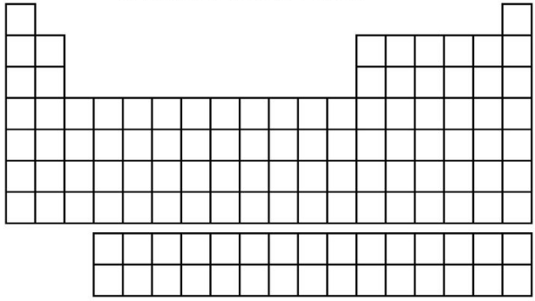
Write the atomic number & symbol for all elements found in the table above.

